TRAVEL INFORMATION VIENNA

Arriving by plane at Vienna Airport Schwechat (19 km from city centre):

By taxi:
Take a so-called Airport-Taxi. The ride will take approx. 45 minutes and cost about EUR 50.

By tRain:
There are two possibilities how to travel to the city. You may

- take the “Vienna Airport Train – CAT” – you can easily find the station at the airport by following the signs to “CAT”. Driving time is approx. 16 minutes and it leaves every 30 minutes; cost is EUR 11 for a one-way ticket. Trains are easy accessible. For more information see the web: https://www.cityairporttrain.com . Or
- change to a train (a so called “Schnellbahn”) going to the station “Praterstern”. The station at the airport is easy to find from the arrivals lounge. It is a little bit difficult to access the trains – no help for disabled persons or with your luggage. Cost for the ticket is EUR 3.90 one way. At “Praterstern” you have to change to underground line U2 (direction Seestadt Aspern) to the station “Messe Prater”.

By Vienna Airport Lines bus service:
Take the bus outside the arrivals terminal, direction “Schwedenplatz/Morzinplatz”, to the station “Schwedenplatz”. Tickets are available from the driver (EUR 8 for a single journey). Journey takes approx. 20 minutes. (For more information see the airport information at the web: http://www.viennaairport.com - arrival and parking).
Change to the underground line U2 (direction Seestadt Aspern) and exit at the station “Messe Prater”.

Tickets for the Public Transportation System in Vienna:

You can buy all tickets at the ticket machines in the underground stations and in tobacconists shops (“Tabak Trafik”) or buy one in the tram. Please note: there are no ticket machines inside the underground trains and those tickets bought in trams are a little more expensive than those bought in advance.

Tickets available are:

The Single Trip Ticket – can be used for one journey in one direction; price is EUR 1.80 at the tobacconist or ticket machine and EUR 2.20 inside the tram. No ticket machines inside the underground lines!
The “Wiener Einkaufskarte” (Vienna Shopping Card) - for those who want to travel within Vienna between 8:00 a.m. and 8:00 p.m.; cost is EUR 4.60
The 24-hour Ticket - The 24-hour Vienna card at EUR 5.70 may be used throughout Vienna for exactly 24 hours from the time it is validated.
The "72-hour Ticket" – can be used for all journeys within Vienna for exactly 72 hours after validation. Cost is EUR 13.60
The "Wien-Karte" – can be used for all journeys within Vienna for exactly 72 hours and also offers a price reduction for some museums and restaurants. Price is EUR 18.50
The "8-day-Ticket" – can be used by up to 8 persons using public transport in Vienna at the same time. It can be used on the day of validation until 1 a.m. the next day. One section must be stamped per person/per day at the (blue) stamping box. Cost is EURO 28.80

How to find our institute:

From Hotel IBIS Wien Messe
(Lassallestraße 7a, 1020 Wien)

Hotel ibis is in walking distance from the train/underground station „Praterstern“ and to/from the WU campus:

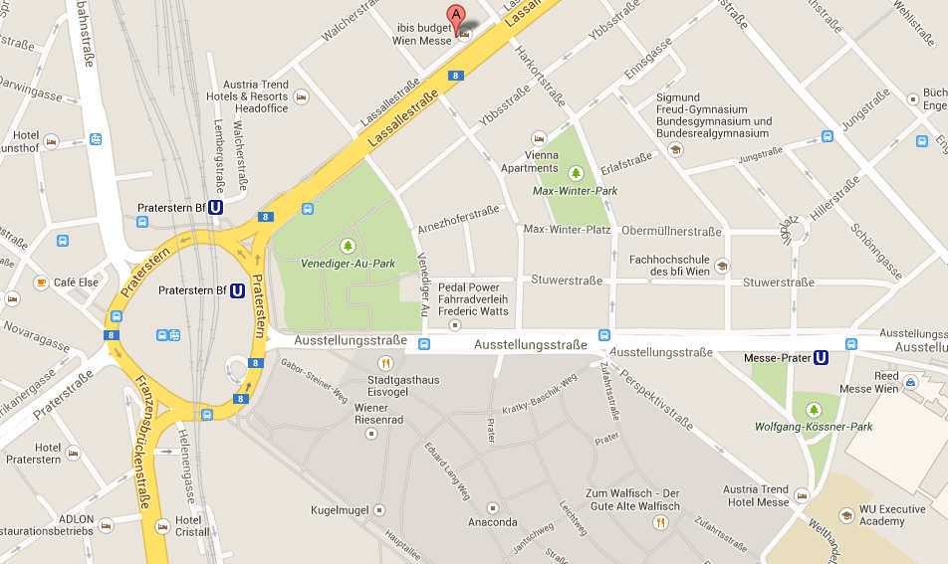
WU Vienna University of Economics

For details about the campus see the next map. Please contact us if there are any questions or problems!
(Ursula - +43 (0)1 31336 4777 during office hours)

WU – Vienna University of Economics and Business – Campus Prater

Our Building „D4“:
Entrance/Lounge in the 3rd floor
Tel. 01-31336 4777 – Grafeneder/Gaal

Link for more information: http://www.wu.ac.at/campus/overview
Entrance to the Campus
Or search with utmost precision: http://gis.wu.ac.at/

